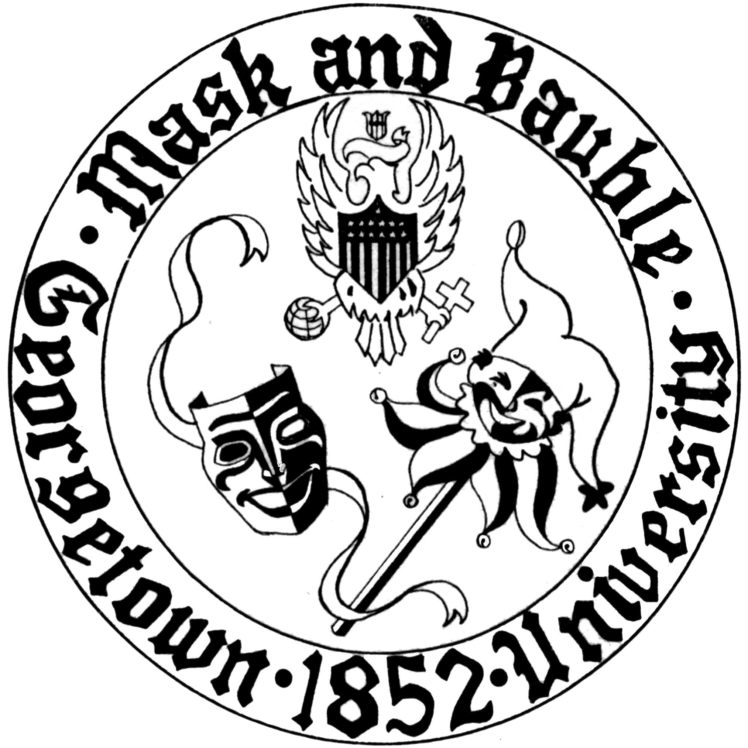
Mask and Bauble Dramatic Society
of Georgetown University

News for Immediate Release

Mask and Bauble Dramatic to Present Rumors by Neil Simon
The nation’s oldest continuously-running student theatre organization will present Simon’s celebrated 1988 farce in Stage III October 12-21st

WASHINGTON, DC – October 2, 2017 – Mask and Bauble Dramatic Society will present its first-ever performances of Neil Simon’s Rumors from October 12th to 21st in its home, Poulton Hall Stage III. The comedy, directed by Ryan Seideman (COL ‘19) and produced by Colton Wade (SFS ‘18/MSFS’19), is the first of M&B’s four mainstage productions this season.

Rumors follows the hijinks surrounding the tenth wedding anniversary party of deputy mayor of New York City, Charley Brock. At the outset of the play, Charley has shot himself in the ear, his wife, Myra, is missing, and the imminent arrival of a colorful group of guests threatens to implicate them all in an uproarious scandal.

“The process has been so much fun up to this point. The cast has been so easy to work with and all of them have shown fantastic comedic instincts, which is so important in farce. I'm thrilled to see what the finished product will yield, and I know that the hard work of so many wonderful people will ultimately pay off,” says director Ryan Seideman about the play.

First presented on Broadway in 1988 with a cast that included Christine Baranski, Jessica Walters, and Andre Gregory, among others, Rumors is set in the well-to-do New York suburb of Sneden’s landing; “'The play started with the idea of doing a farce...The next thing was to do it as an elegant farce, because the farces in Moliere's days were generally about wealthy people,” said Simon in a 1988 interview with the New York Times. “These aren't extremely wealthy people, but they are well-to-do.”

M&B’s production of Rumors features a cast of Madison Carter (COL ’21) (Cassie Cooper), Kate Clark (COL ‘21) (Cookie Cusack), Sarah Cope (SFS ‘21) (Officer Pudney), Sam Cormier (COL 21) (Lenny Ganz), Abi Franklin (COL ‘19) (Chris Gorman), Jenni Loo (SFS ‘21) (Claire Ganz), Harry Rose (COL ‘20) (Ernie Cusack), Dan Ruescher (COL ‘20) (Ken Gorman), Isaac Warren (COL ‘20) (Glen Cooper), and Bernadette Yamakaitis (SFS ‘21) (Officer Welch), and technical direction by Katie Morgan (COL ‘20). Daniel Wheelock (COL ‘19) serves as stage manager.

Tickets are available online here, and information about rumors can be found here. Performances are on October 12th, 13th, 14th, 18th, 19th, 20th, and 21st at 8 PM, and October 15th at 2 PM in Poulton Hall Stage III.
For more information about Season 166, Mask and Bauble’s leadership, and upcoming events, please visit M&B’s website. M&B is also active on Facebook and Instagram. Stage III is located in Poulton Hall at 1421 37th Street, NW, Washington, DC 20007.

Please direct all questions to maskandbauble@gmail.com.
Public relations by Board 166 Publicity Director Harry Rose (COL’20).

