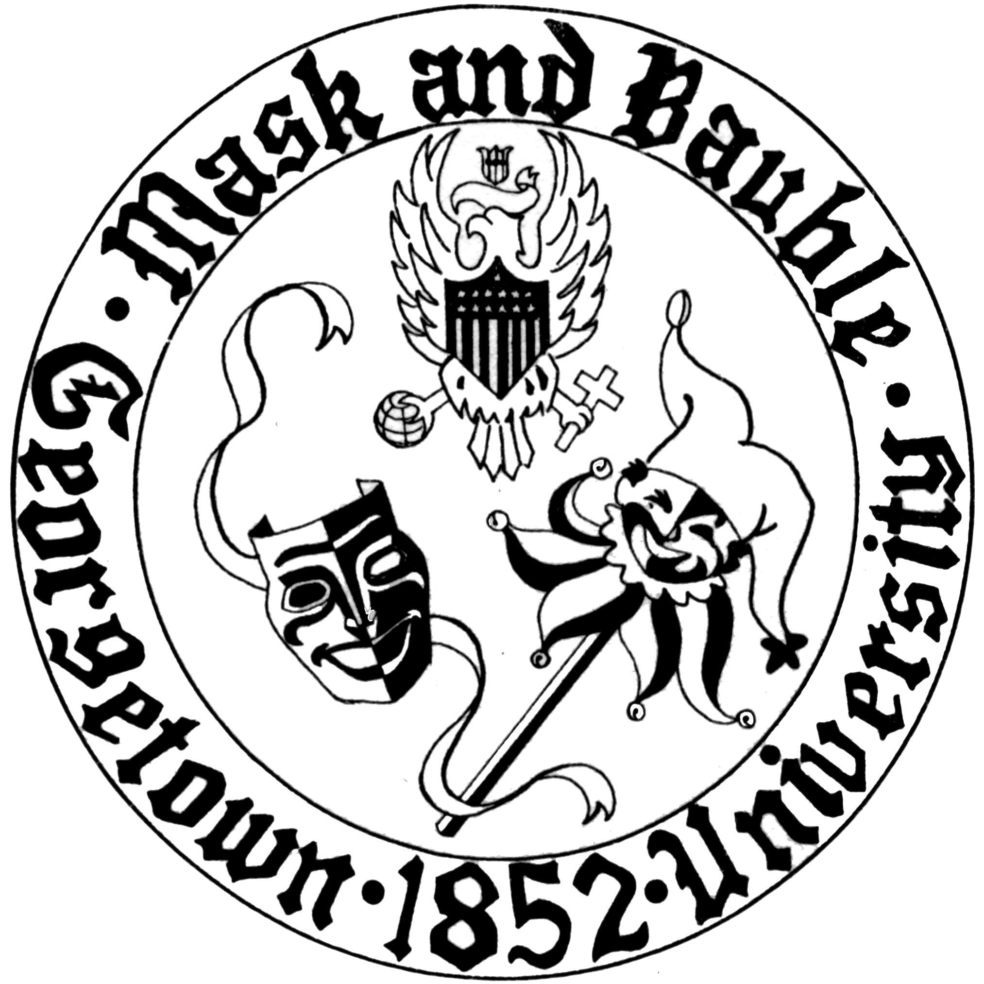
Mask and Bauble Dramatic Society
of Georgetown University

News for Immediate Release

Mask and Bauble Dramatic Society Presents Staged Reading of Aaron Posner’s My Name is Asher Lev
The nation’s oldest continuously-running student theatre organization will present a staged reading of Posner’s play on October 1st, 2017

WASHINGTON, DC – September 21st, 2017 – Mask and Bauble Dramatic Society will present a one-performance staged reading of Aaron Posner’s My Name is Asher Lev, directed by Ari Shapiro (SFS ‘18) as the first of its Stage IV productions on October 1st in the Healy Family Student Center’s Herman Room at 7 PM.

Based on the novel by Chaim Potok and set in a Hasidic community in Brooklyn, New York, Asher Lev concerns the cultural clash that occurs when the Hasidic Jewish artist Asher Lev finds his artistic tendencies in direct conflict with his religious community. "The play dives head-first into issues of religious difference. By exploring western art through the lens of a religious Jew's experience, it asks far more questions than it answers about the relationship between community, religion, and individual expression,” says Shapiro about the play. “Exploring these questions in rehearsal with the cast has been a profound exercise, especially in light of the recent expressions of hatred on this campus.”

My Name Is Asher Lev was originally presented in 2009 at the Arden Theatre Company in Philadelphia and has since run off-Broadway and received numerous regional presentations. This performance is the first Stage IV performance of Season 166. The Stage IV series is focused on small-scale, enterprising performances that offer opportunities to act, direct, stage manage, or produce in a lower-time commitment atmosphere than mainstage productions. On a more condensed time frame than mainstage shows, M&B strives to offer as many Stage IV performance opportunities as possible. The next stage IV performance will be M&B’s annual presentation of Charles Dickens’ A Christmas Carol following the Dahlgren Tree Lighting Ceremony on December 1st.

M&B’s production of My Name is Asher Lev features Jonathan Bigler-Lisch (‘21) as Asher Lev, Nolan Peacock (‘21) as The Men, and KJ Moran (COL ‘18) as The Women. Gabriela Czerniawski (COL ‘20) serves as stage manager.

Tickets for My Name is Asher Lev are free and the performance is open to the public. The performance takes place October 1st, 2017 at 7PM in the Healy Family Student Center Herman Room.
For more information about Season 166, Mask and Bauble’s leadership, and upcoming events, please visit M&B’s website. M&B is also active on Facebook and Instagram.

Please direct all questions to maskandbauble@gmail.com.
Public relations by Board 166 Publicity Director Harry Rose (COL’20).

