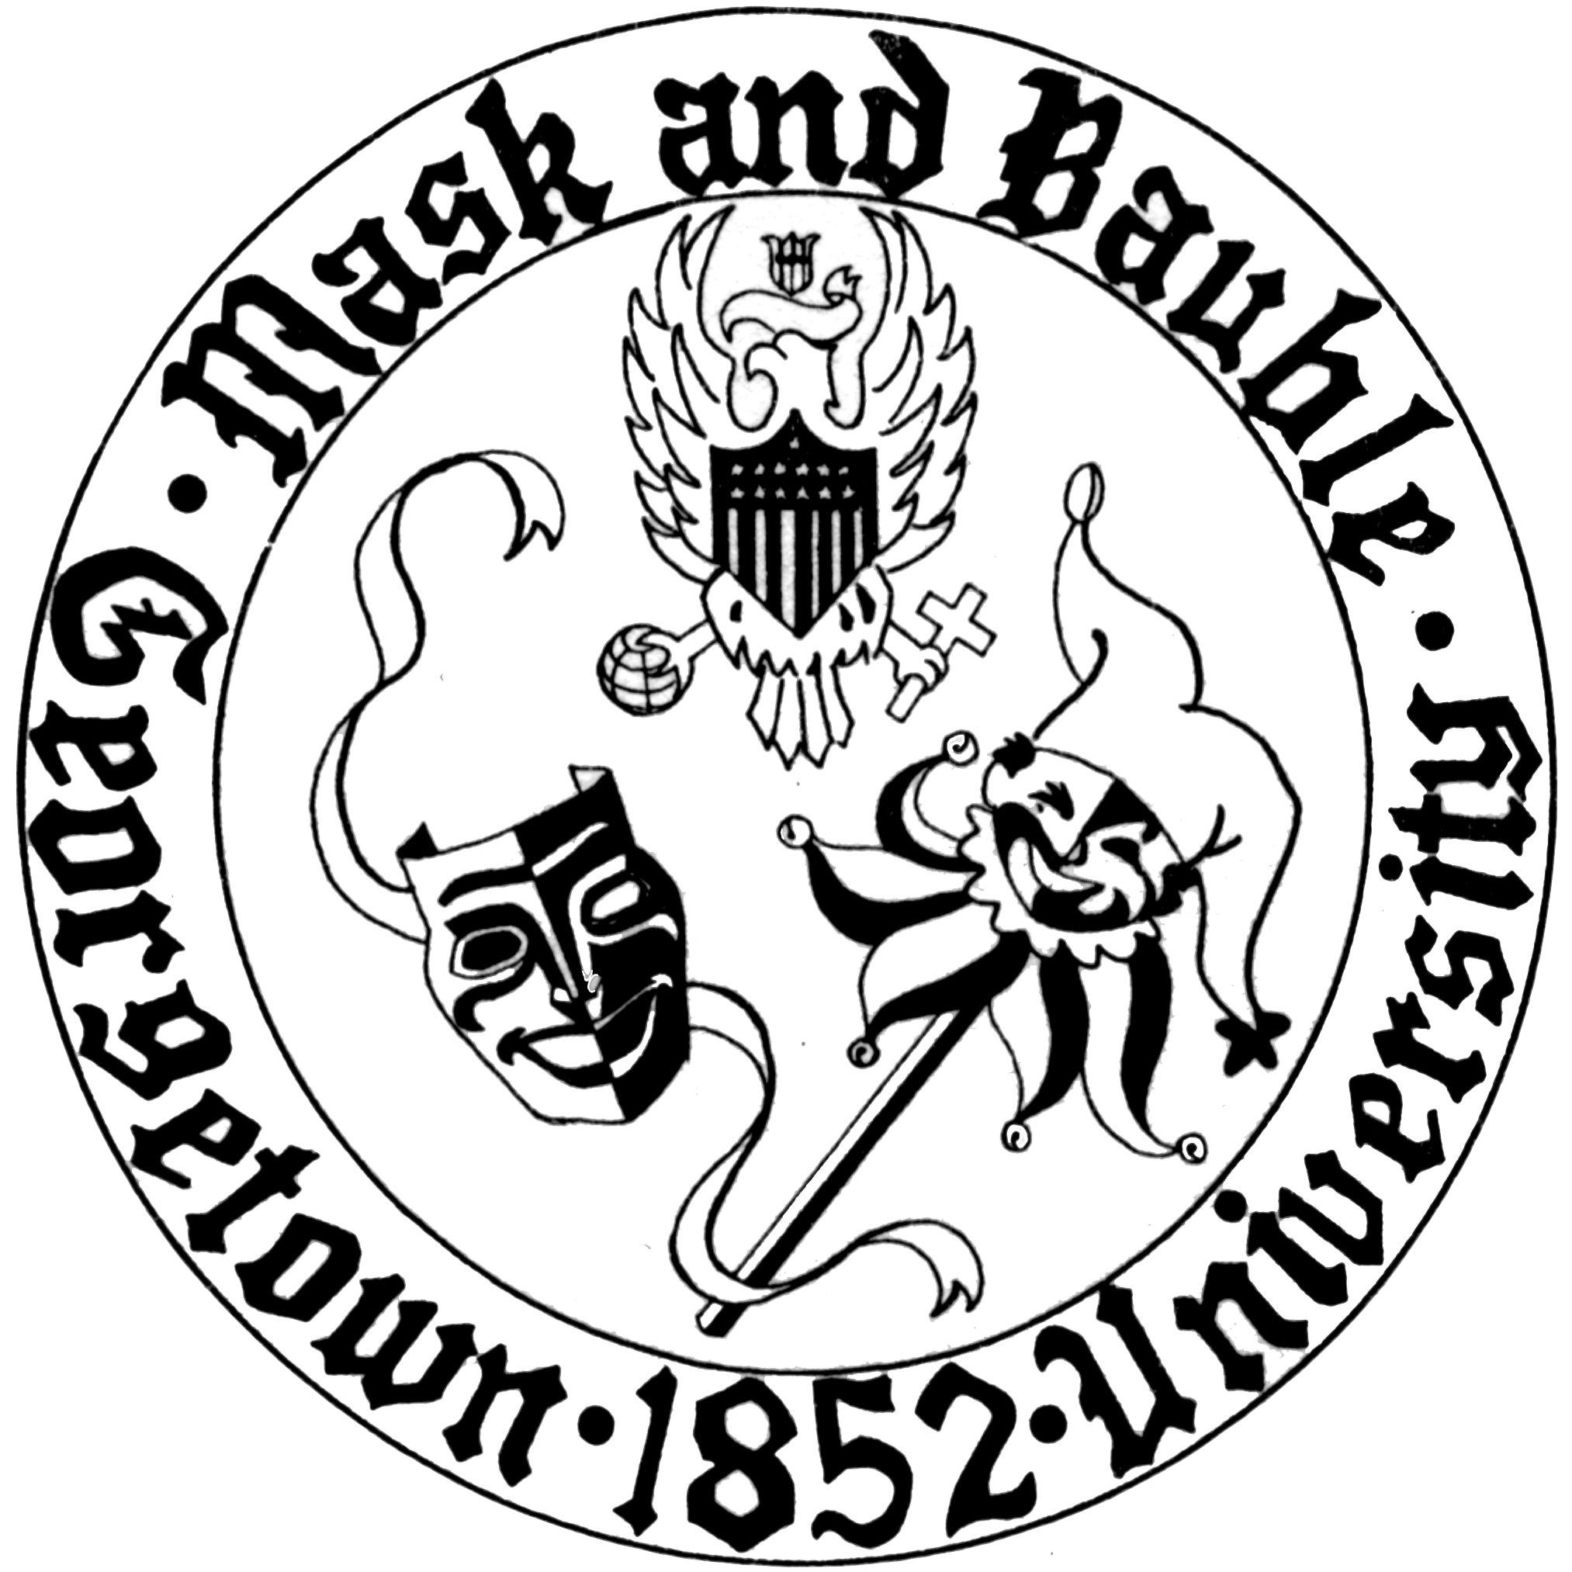
Mask and Bauble Dramatic Society
of Georgetown University

News for Immediate Release

Mask and Bauble Dramatic to Present the 32nd Donn B. Murphy One Acts Festival featuring Roots by Devika Ranjan (SFS ’17)
The nation’s oldest continuously-running student theatre organization will present a week of student-written works in Stage III November 13-18th

WASHINGTON, DC – October 27, 2017 – For its second mainstage production of the year, Mask and Bauble Dramatic Society will present a week of performances of Roots by Devika Ranjan (SFS ’17), student-written staged readings, and performances by other extracurricular groups as part of its 31st annual Donn. B Murphy One Acts Festival (DBMOAF). Taking on a reenergized festival structure, different plays and ensembles will be presented every night during the week of November 13-18th. “The structure of this year’s festival is something we were really excited to work with as a directing staff going into this process. Previous DBMOAFs have typically performed one or two selected plays for every night of the festival,” said producer Christian Collier (COL ’19). “Our goal with this year’s festival was to showcase more one-act plays and to feature works from other student performance groups on campus.”

Named for the legendary faculty advisor of Mask & Bauble from 1956 to 1976 and Theatrical Advisor to Presidents Kennedy and Johnson, Donn B. Murphy, this season’s DBMOAF marks 32 years of a structured presentations of student-written work. Born out of the tradition of “Calliopes,” student-written and devised musicals that Dr. Murphy encouraged and championed during his tenure at Georgetown, the annual student-written one-acts festival constitutes an indelible pillar of M&B’s annual programming and is the only such outlet for full-scale productions of student-written works at Georgetown. “What's so great about this process is that because it's all new work, it fosters so much collaboration. The cast is creating characters that have never been seen before, the designers are creating this world from scratch, and because everyone is working so closely together, everyone forms such strong bonds with each other,” observed director Gabriel Berkowitz (MSB ’20).

At the center of this year’s DBMOAF is Ranjan’s Roots. Both poignant and insightful, Roots details the struggle of Richa, a young Indian woman who faces exclusion and prejudice in her new suburban neighborhood, only to watch the façade of perfection crumble when Jane, the mean mom in charge, is served divorce papers and an eviction notice. Also included during the week of performances are staged readings of Diagnos-Mis by Vanessa Chapoy (COL ’18) and Evelyne by Claire Deriennic (COL ’17).

In Diagnos-Mis, when doctors attribute Adriana’s learning disability to her bilingual upbringing, she struggles to reconcile with her culture and her language in the days before her quinceañera, while in Evelyne, an older French-Jewish woman reflects on being baptized during her childhood in France during World War II in order to survive the liberation of Paris. The plays presented will be paired with performances by co-curricular groups Ballet Folklórico Mexicano de Georgetown, GU Harmony, and Corpus on alternating nights. A schedule of the Festival can be found below.

“The stories we're telling in this year's festival all revolve around culture and identity, and having groups like GU Harmony and Ballet Folklórico with us has really strengthened that,” says Berkowitz. “We have French music for Evelyne and we have traditional Mexican dance for Diagnos-Mis. I really wanted to involve these groups not just to have added entertainment but to really play up the importance of these cultural elements to the characters.”

Roots features performances by Asha Merz (COL ’20) as Richa, Grace Crozier (COL ’21) as Jane, Madeline Warner (COL ’21) as Maggie, Nicole Albanese (COL ’20) as Mary, and Rachel Lock (COL ’20) as Kat. Colum Goebelbecker (COL ’21), Andrew Molinari (COL ’21), and Samuel Nelson (COL ’21) play the Gnomes who serve as a Greek chorus throughout the play. Diagnos-Mis features Nicki Gray (NHS ’20), Teresa Montanero (COL ’20), Lydia Fernandez (COL ’20), and Samuel Nelson (COL ’21). The cast of Evelyne includes Asha Merz (COL ’20), Grace Crozier (COL ’21), Madeline Warner (COL ’21), Nicole Albanese (COL ’20), Rachel Lock (COL ’20), Colum Goebelbecker (COL ’21), and Andrew Molinari (COL ’21).

DBMOAF is produced by Christian Collier (COL ’19) and directed by Gabriel Berkowitz (MSB ’20). The Festival features technical direction by Kali Sullivan (COL ’19) and is stage managed by Chanel Cai (COL ’20).

Tickets are available online here, and information about DBMOAF can be found here. Performances are on November 14th, 15th, 16th, and 17th at 8 PM, and November 18th at 2 PM in Poulton Hall Stage III.
For more information about Season 166, Mask and Bauble’s leadership, and upcoming events, please visit M&B’s website. M&B is also active on Facebook and Instagram. Stage III is located in Poulton Hall at 1421 37th Street, NW, Washington, DC 20007.

Schedule of 32nd DBMOAF:

Tuesday, November 14 at 8 pm:
Roots by Devika Ranjan (SFS '17)
Diagnos-Mis by Vanessa Chapoy (COL '18) featuring Ballet Folklórico
Wednesday, November 15 at 8 pm:
Evelyne by Claire Derriennic (COL '17) featuring GU Harmony
Roots by Devika Ranjan (SFS '17)
Thursday, November 16 at 8pm:
Evelyne by Claire Derriennic (COL '17) featuring GU Harmony
Roots by Devika Ranjan (SFS '17)
Friday, November 17 at 8pm:
Roots by Devika Ranjan (SFS '17)
Corpus
Talkback featuring Devika Ranjan (SFS '17)
Saturday, November 18 at 2 pm:
Roots by Devika Ranjan (SFS '17)
Diagnos-Mis by Vanessa Chapoy (COL '18) featuring Ballet Folklórico

Please direct all questions to maskandbauble@gmail.com.
Public relations by Board 166 Publicity Director Harry Rose (COL’20).

