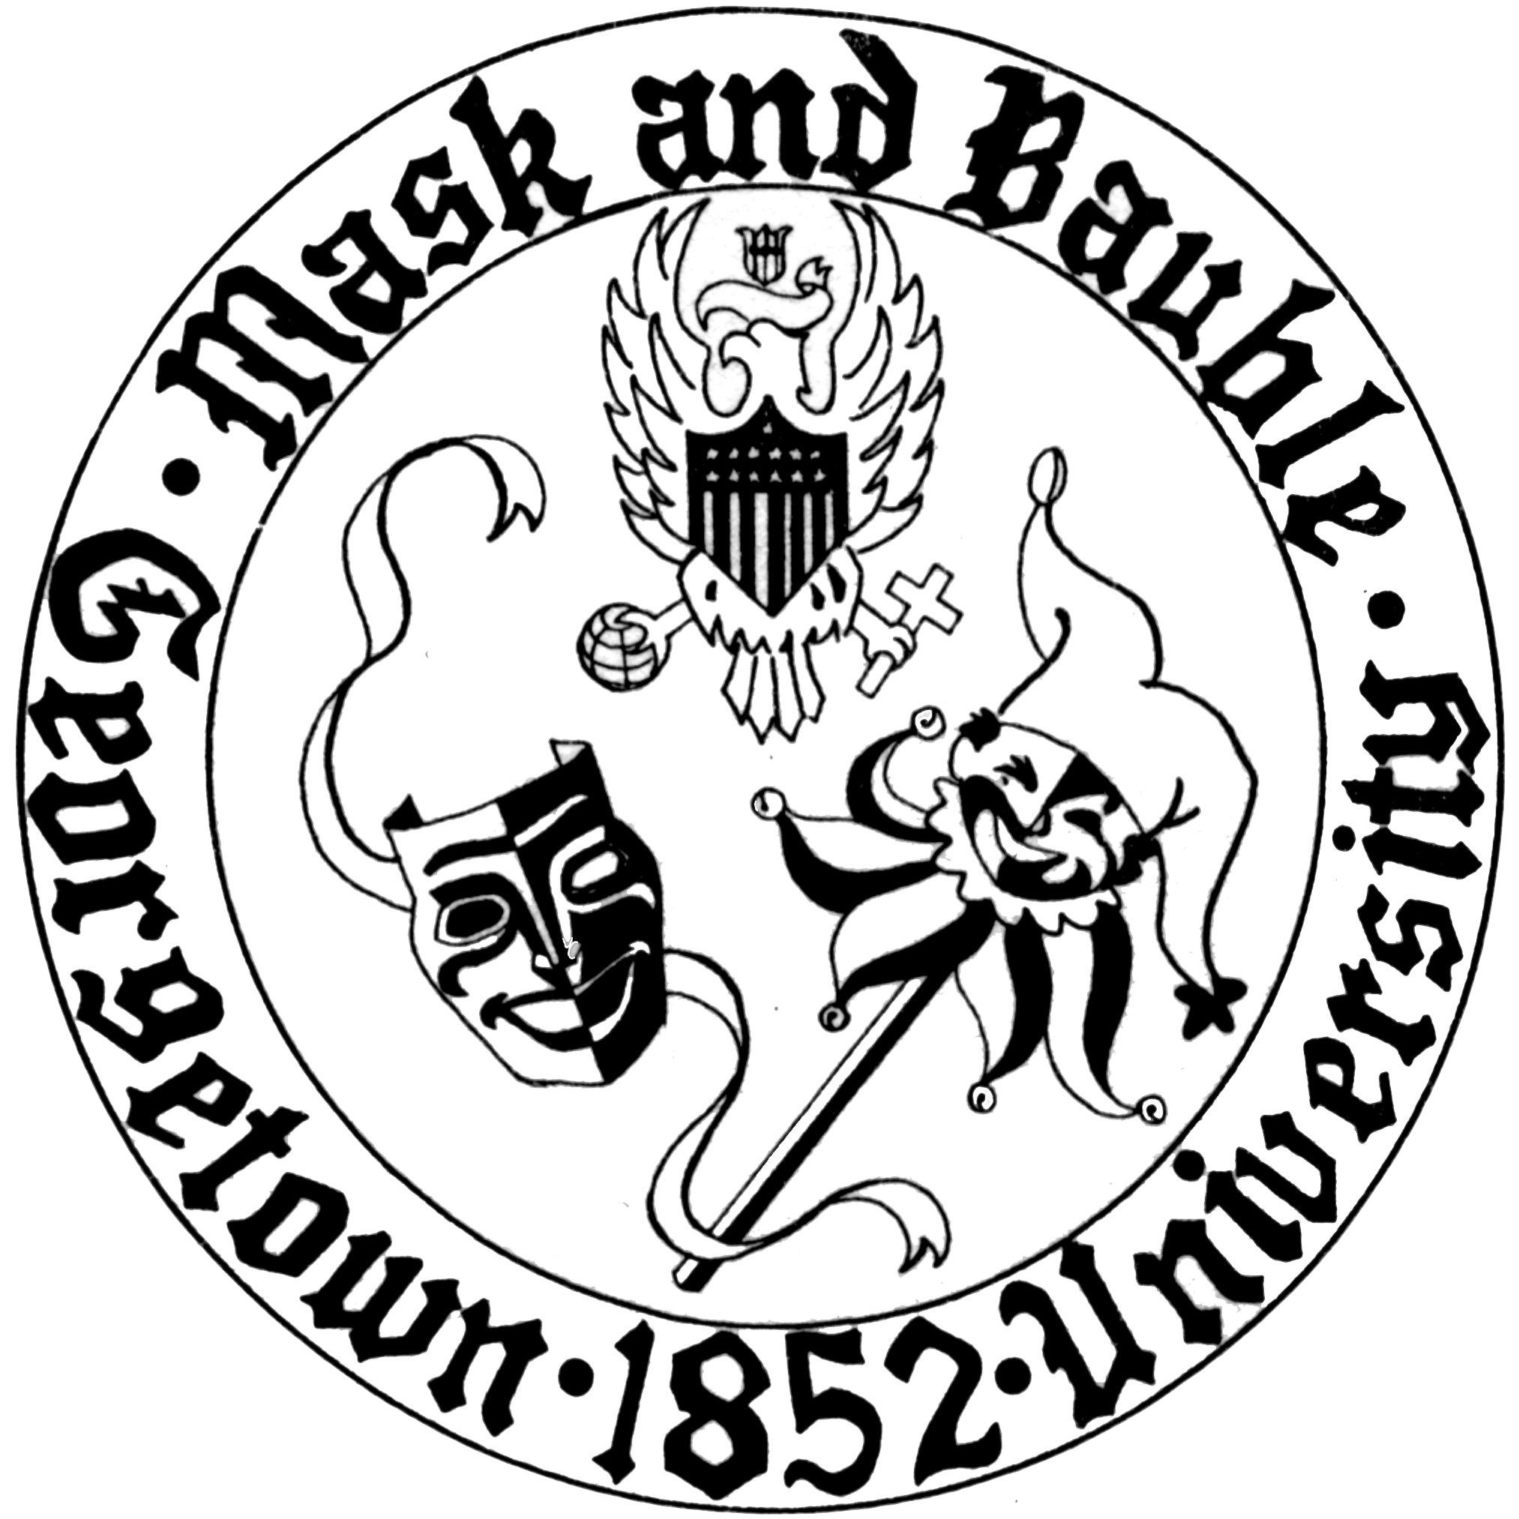
Mask and Bauble Dramatic Society
of Georgetown University

News for Immediate Release

Mask and Bauble Dramatic Society Announces its 166th Season
The nation’s oldest continuously-running student theatre organization will grapple with life’s unexpected events and how we respond to them

WASHINGTON, DC – August 3, 2017 – Season 166, dubbed “Incredibly Rare and Dangerously New,” includes Rumors, an expanded student-written one-acts festival in honor of Donn B. Murphy, Mr. Burns, a Post-Electric Play in a co-production with nomadictheatre, and the musical Footloose, all in Mask & Bauble’s home, Poulton Hall, Stage III.

Georgetown University’s Mask and Bauble Dramatic Society (M&B) concluded a successful 165th Season in April with a production of Aaron Posner’s adaptation of Anton Chekhov’s The Seagull, Stupid F##king Bird, and is excited to announce a new season of mainstage productions that aims to challenge audiences, illuminate the qualities that make us human, and reach new demographics as the club celebrates its 166th year.

The fall will see a presentation of Neil Simon’s Rumors under the direction of Ryan Seideman (COL’19). Simon’s sardonic farce, first premiered in 19988, dives head-first into a chaos-fraught dinner party at the home of the Deputy Mayor of New York City. Coverups and hijinks ensue in a production produced by Colton Wade (SFS’18) and featuring stage management and technical direction by Daniel Wheelock (COL’19) and Katie Morgan (COL’20). Rumors runs October 12-15 in Poulton Hall Stage III. More information about performance dates and times is available here.

M&B’s next presentation is a celebration of student-written work. The Donn B. Murphy One Acts Festival (DBMOAF) takes place over the week of November 14th to November 18th with a full production of Roots, the DBMOAF competition-winning play by Devika Ranjan (SFS’17), as its centerpiece. Roots tells the story of an Indian woman who confronts exclusion and hostility in her new community. Helmed by the director/producer team of Gabriel Berkowitz (MSB’20) and Christian Collier (COL’19), DBMOAF includes staged readings of Vanessa Chapoy’s (COL’18) Diagnos-Mis and Claire Deriennic’s (COL’17) Evelyne as well as performances by other co-curricular groups. Chanel Cai (COL’20) and Kali Sullivan (MSB’19) provide stage management and technical direction. More information about Season 166’s DBMOAF is available here.

For its first production of the spring semester, M&B partners with nomadictheatre to present Anne Washburn’s Mr. Burns, a Post-Electric Play. Mr. Burns examines a ragtag group of survivors’ attempt to reproduce an episode of The Simpsons from memory in a mythological, post-apocalyptic America. Johnny Monday (COL’18) directs this meditation on despair, resilience, and the power of artistic expression in times of compromise. Cameron Bell (COL’19) produces a production that is stage managed and tech directed by Amelia Walsh (SFS’20) and Leyland Reilly (SFS’20). Mr. Burns runs January 18-27. More information available here.

Season 166 comes to an exuberant conclusion with a production of Footloose, directed by Annie Ludtke (MSB’18). Taken from the synonymous 1984 movie and featuring music by Tom Snow, lyrics by Dean Pitchford and Kenny Loggins, and a book by Dean Pitchford and Walter Bobbie, Footloose explores the consequences when an outsider sets his mind to changing the provincial town of Bomont’s most outlandish law: a ban on dancing. Board 166 Technical Director Ben Sullivan (COL’19) produces the uplifting musical that features musical direction and choreography by Abi Franklin (COL’19) and Lexi Schiazza (COL’19). Emma Hough (COL’20) and Jonathon Compo (NHS’20) stage manage and tech direct this final production of Season 166 in Poulton Hall Stage III, April 11-21. Further information can be found here.

Mask and Bauble’s 166th season will also feature numerous, smaller-scale “Stage IV” productions, an open-house day, and an annual performance of Charles Dickens’s A Christmas Carol in December. Dates and further information for these events will be announced in the coming months.

For more information about Season 166, Mask and Bauble’s leadership, and upcoming events, please visit M&B’s website. M&B is also active on Facebook and Instagram. Stage III is located in Poulton Hall at 1421 37th Street, NW, Washington, DC 20007.

Please direct all questions to maskandbauble@gmail.com.
Public relations by Board 166 Publicity Director Harry Rose (COL’20).

